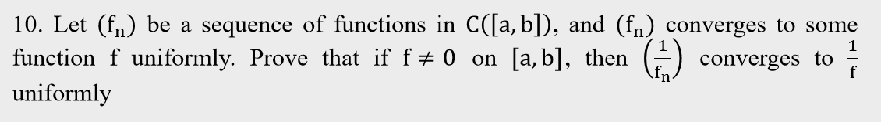

Proof: Since $f≠0$ and $\left(f_{n}\right)$ converges to f uniformly, there is some $M ϵ N$ such that $∀n>M_{1}, f_{n}≠0$. $∀ε>0$, there is some $M_{2}≥M_{1}$ such that $∀n>M_{2}, ∀x ϵ \left[a,b\right], \left|f_{n}\left(x\right)-f\left(x\right)\right|<ε∙0.5{\left(minf\right)}^{2}$. Choose some $M_{3}≥M_{1}$ such that $∀n>M_{3}, {minf}_{n}≥0.5minf$. Fix this $ε$, for any $n>M_{3}$ we have $\left|\frac{1}{f\left(x\right)}-\frac{1}{f_{n}\left(x\right)}\right|=\left|\frac{f_{n}\left(x\right)-f\left(x\right)}{f\left(x\right)f_{n}\left(x\right)}\right|<\frac{ε∙0.5{\left(minf\right)}^{2}}{0.5minf∙minf}=ε$ for any $x ϵ [a,b]$. Therefore, the function sequence $(\frac{1}{f_{n}})$ converges uniformly to $\frac{1}{f}$.

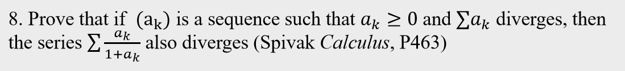

Proof: If the sequence $(a_{k})$ is not bounded, then there is some subsequence $(a_{n_{k}})$ such that $\lim{a_{n_{k}}}=+∞$. This means $\lim{\frac{a_{n_{k}}}{1+a_{n_{k}}}}=1$. It follows that for some $M ϵ N$, $\sum{\frac{a_{k}}{1+a_{k}}}≥\sum{\frac{a_{n_{k}}}{1+a_{n_{k}}}}=\sum{\left(1-\frac{1}{1+a_{n_{k}}}\right)}≥\sum_{k≥M}{\frac{a_{n_{k}}}{1+a_{n_{k}}}}>\sum_{k≥M}{\frac{1}{2}}=+∞$. Therefore, the series diverges. If the sequence $(a_{k})$ is bounded, we investigate the ratio of $a_{k}$ and $\frac{a_{k}}{1+a_{k}}$: $\frac{\frac{a_{k}}{1+a_{k}}}{a_{k}}=\frac{1}{1+a_{k}}≥\frac{1}{1+\sup\left(a_{k}\right)}$. This means for any n, $\sum_{k=0}^{n}{\frac{a_{k}}{1+a_{k}}}≥\frac{1}{1+\sup\left(a_{k}\right)}∙\sum_{k=0}^{n}{a_{k}}$. Note that $\frac{1}{1+\sup\left(a_{k}\right)}$ is nothing but a positive number. Thus, $\sum{\frac{a_{k}}{1+a_{k}}}$ diverges.